SUBCOURSE EDITION
IT0300 C

US ARMY INTELLIGENCE CENTER

ELEMENTARY SIGNAL THEORY

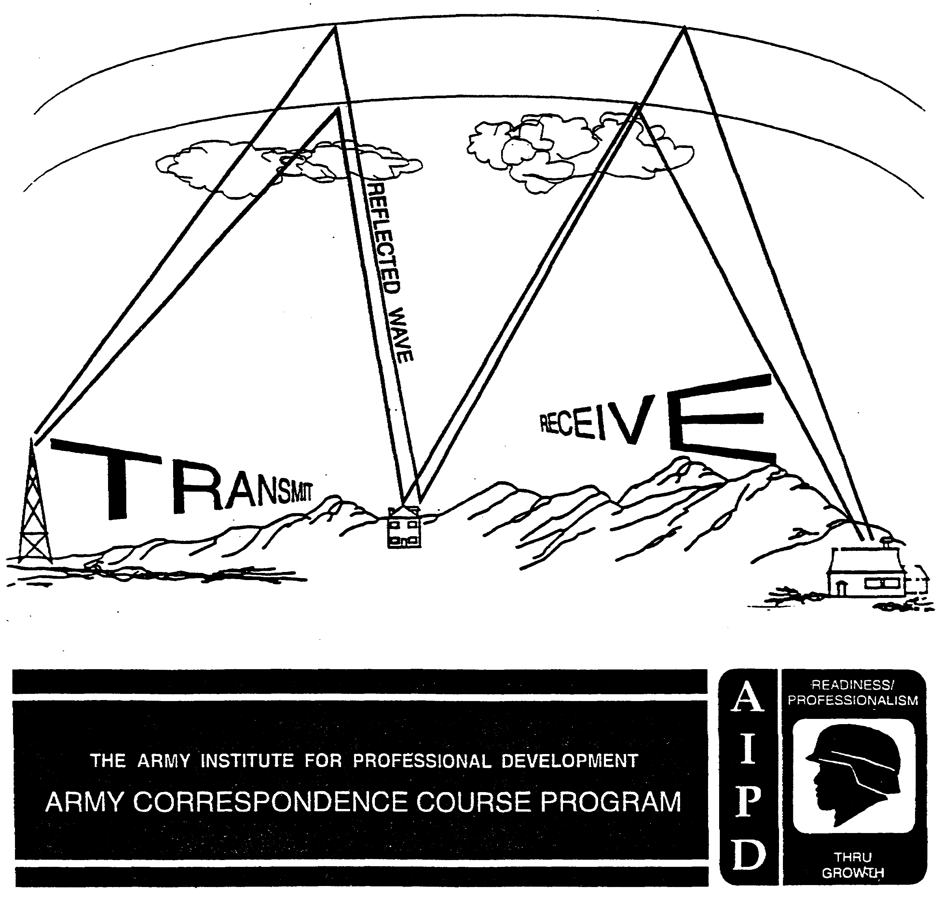

ELEMENTARY SIGNAL THEORY

Subcourse Number IT0300

Edition C

US ARMY INTELLIGENCE CENTER
FORT HUACHUCA, AZ 85613-6000

4 CREDIT HOURS

EDITION DATE: June 1999

SUBCOURSE OVERVIEW

This subcourse is intended as an introduction to radio waves, their characteristics, and elementary wave propagation concepts. It is applicable to personnel in Career Management Field 98 or anyone who must understand how radio signals travel from point to point and how the locations of receiving and transmitting antennas affect radio reception at different radio frequencies.

There are no prerequisites for this subcourse.

Unless otherwise stated, the masculine gender of singular pronouns is used to refer to both men and women.

TERMINAL LEARNING OBJECTIVE

ACTION: You will identify characteristics of wave forms, apply basic terminology, and identify how radio waves travel at different frequencies from one location to another.

CONDITION: You will use the information provided in this subcourse.

STANDARD: To demonstrate competency of this task, you must achieve a minimum of 70 percent on the subcourse examination.

i IT0300

TABLE OF CONTENTS

Section Page

Subcourse Overview i

Lesson 1: Waves and Wave Characteristics 1-1

Practice Exercise 1 1-12

Answer Key and Feedback 1-16

Lesson 2: Radio Waves and Propagation 2-1

Practice Exercise 2 2-11

Answer Key and Feedback 2-16

IT0300 ii

LESSON 1

WAVES AND WAVE CHARACTERISTICS

Critical Task: 301-98K-1302

OVERVIEW

LESSON DESCRIPTION:

Upon completion of this lesson you will be able to:

In this lesson you will identify period, frequency, amplitude and simplified examples of wave mixing when provided with a diagram of waves and their associated characteristics.

TERMINAL LEARNING OBJECTIVE:

TASK: Identify period, frequency and amplitude of a sine wave.

CONDITION: Given the information provided in this subcourse.

STANDARD: To demonstrate competency of this task, you must achieve a minimum of 70 percent on the subcourse examination.

REFERENCES: The material contained in this lesson was derived from the following publications:

Elements of Signal Theory (EOST), Methods of Modulation (MOM), and Communications Electronics Fundamentals: Transmission Lines, Wave Propagation, and Antennas (FM 11-64).

INTRODUCTION

1. The word wave at first glance is not difficult to understand. A flag waving in the breeze, trees swaying to and fro from nature's gentle pull, a father waving to his children, a surfer riding a wave to the beach, are all visual experiences of the actions of waves. The tick of a clock, the swinging arm of a metronome, and the vibrant beat of a jazz band combine sight and sound to further define and reinforce the definition of the action of waves. As long as our senses aid us, we have little difficulty in understanding the actions of waves.

But what about those waves that exist beyond our sensory experience, or those that we experience but are totally unaware of the wave action involved -sunburns, words on a printed page, X-ray sensing devices at commercial air terminals, long distance telephone calls, cooking dinner on an electric range, or watching your favorite television program? Without waves or the action of waves these would not exist. Nor in fact would life, as we know it, exist. Understanding waves and their importance as the building block of communications systems is the objective of this lesson. An understanding of waves, sine waves, periodic and aperiodic waves, wave mathematics, wave mixing, and wave propagation is fundamental to successfully completing future lessons on theories of modulation and transmission, transmitters and receivers, and analysis of transmission systems.

1-1 IT0300

Waveform

2. A waveform is a linear graphic representation of an action. The action can continue indefinitely, or it can stop. It can be a certain motion that repeats itself constantly at regular intervals, or it can be an erratic, never repeating sequence of events. Fine! Now what did we really say?

a. Periodic waveforms. Hold a basketball in front of you and about 6 feet from the floor. Drop it and observe the bouncing action. Which of the two following linear graphic representations best shows the action of the basketball (figs. 1-1 and 1-2).

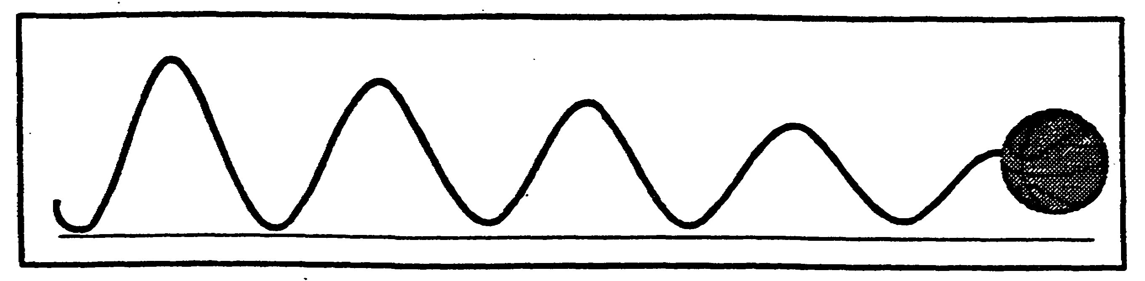

Figure 1-1. Basketball's "Damping" action.

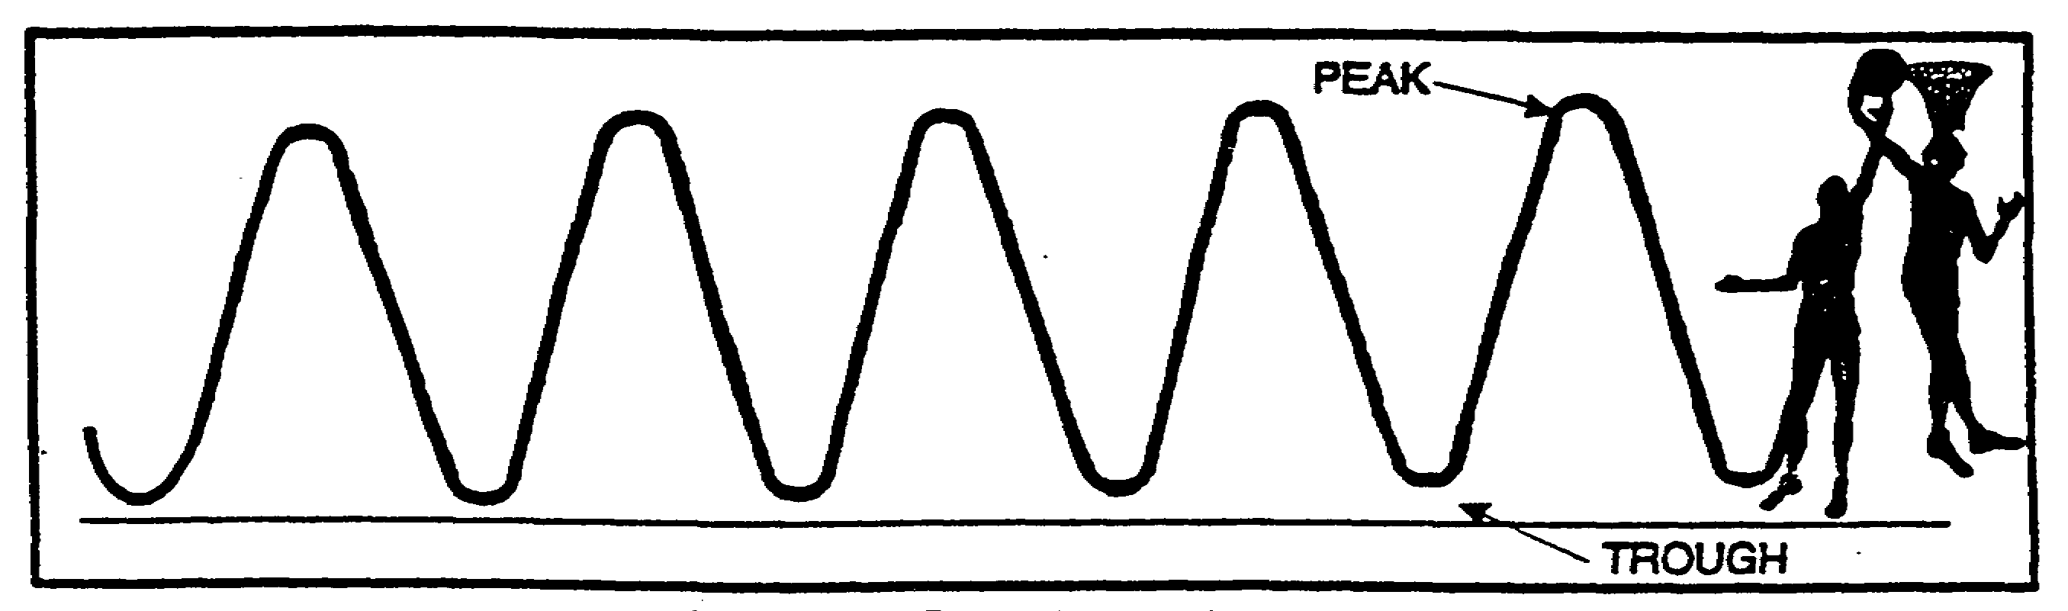

Figure 1-2. Periodic wave's action.

If you chose figure 1-1, you were correct. Without aid the bouncing of the basketball would eventually stop with the basketball coming to rest. The action of the basketball, as represented by figure 1-2 would require some aid or force, such as dribbling. The action described in figure 1-1 is termed damping. The action described in figure 1-2, the constant and regular repetition, is termed periodic wave action. Notice in figure 1-2 that the peak and troughs appear to occur at regular intervals.

IT0300 1-2

b. Aperiodic Waveforms. Now hold a football at arms length and about 6 feet from the floor. Drop it and observe the action. Which of the two following linear graphic representations illustrates the action of the football (figs. 1-3 and 1-4)? If you chose figure 1-3 you were again correct. The bouncing action of the football is not regular or continuously repetitive as the action shown in figure 1-4. The action as illustrated in figure 1-3 is termed aperiodic; i.e., a waveform in which the motion does not repeat itself at constant and regular intervals. The majority of waveforms are of this type.

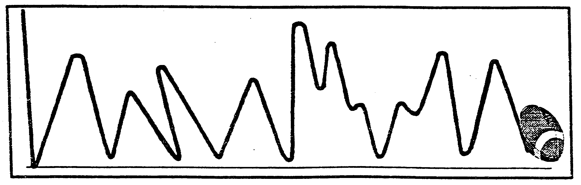

Figure 1-3. Football's action.

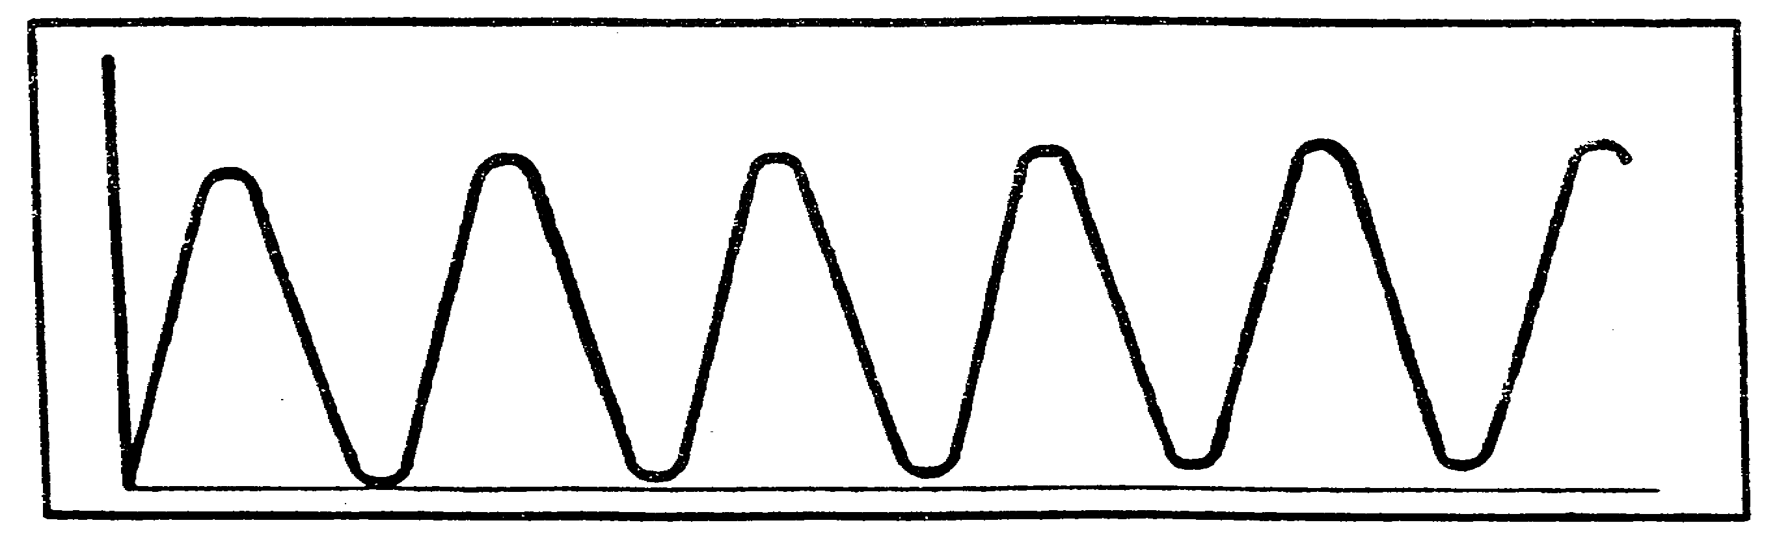

Figure 1-4. Periodic wave's action.

1-3 IT0300

Sine Wave

3. The basic waveform is the sine wave. There is always an aspect of dismay when we toss about terms such as "sine" or "sine wave." We fear being force fed some incomprehensible algebraic and geometric formulations while we are still at the grade school level. Yet, if we were told that a sine wave is only a circle in linear graphic form and that all the components of a circle are also the components of a sine wave, it would be easier to understand. In this lesson we are going to concentrate on your learning the characteristics of a sine wave without the mathematics involved.

a. Circles and Sine Waves. A sine wave may be considered a form of a circle. All the components of a circle directly relate to the analysis of the sine wave characteristics; the radius, the diameter, and degrees. In further subcourses on signal theory the characteristics of intelligence carrying waves will be studied in more detail. At this point it is only necessary to remember that the sine wave and its various combinations of characteristics determine the intelligence carrying capabilities of electromagnetic waves.

b. Degrees. A circle has 360 degrees as does 1 complete cycle of a sine wave. The term sine wave is meant to define the mathematical relationship between certain angles that when plotted on a linear graph will be similar to the examples in figure 1-5. The mathematical generation of the sine wave will be covered in a future lesson.

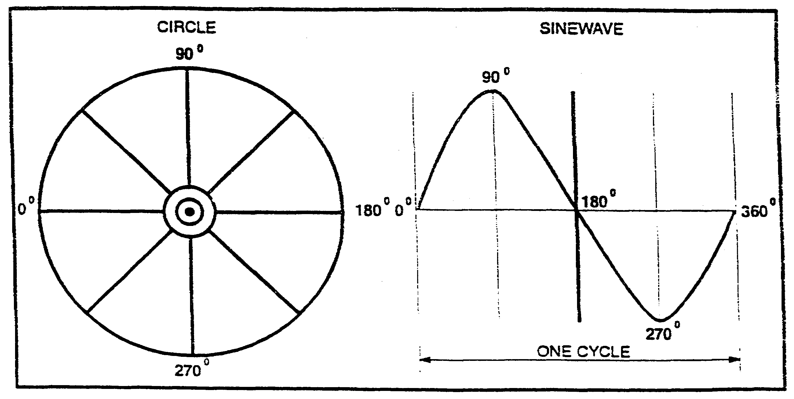

Figure 1-5. Sinewave/circle compared.

c. Cycle. A cycle, if it were a path, would take you on a continuous trip consisting of repeated journeys. Each of the separate, but similar journeys is called a cycle. The term cycle is an important element in understanding other communications and radio fundamentals.

IT0300 1-4

d. Wave Characteristics. The following graphic representation (fig. 1-6) of wave characteristics (amplitude - period - frequency - phase) will serve as the basis for the remainder of this lesson. Become familiar with it.

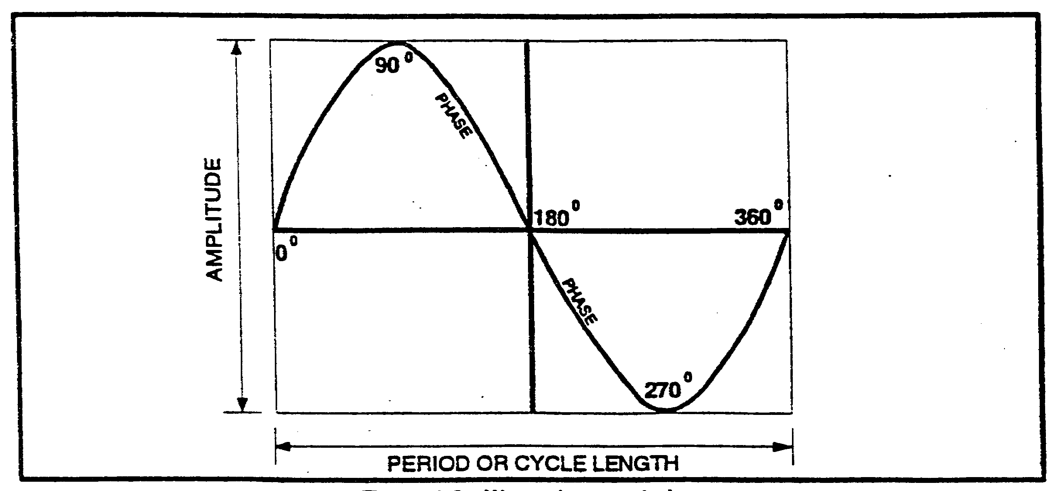

Figure 1-6. Wave characteristics.

(1) Amplitude. In our example of the bouncing basketball, when we dropped it, it returned almost to its original height, and each subsequent bounce was lower until the basketball finally came to rest. Now, if we used our hand to dribble the basketball; i.e., applied force or energy, the ball would return to its original height each time. From this example, we can infer that amplitude, or the height to which the basketball returned, is related to the force or energy applied to sustain the bouncing action or to create a particular waveform. Therefore, we see that the greater or lesser force or energy applied to a waveform will be reflected in a greater or lesser bounce or amplitude (fig. 1-7).

1-5 IT0300

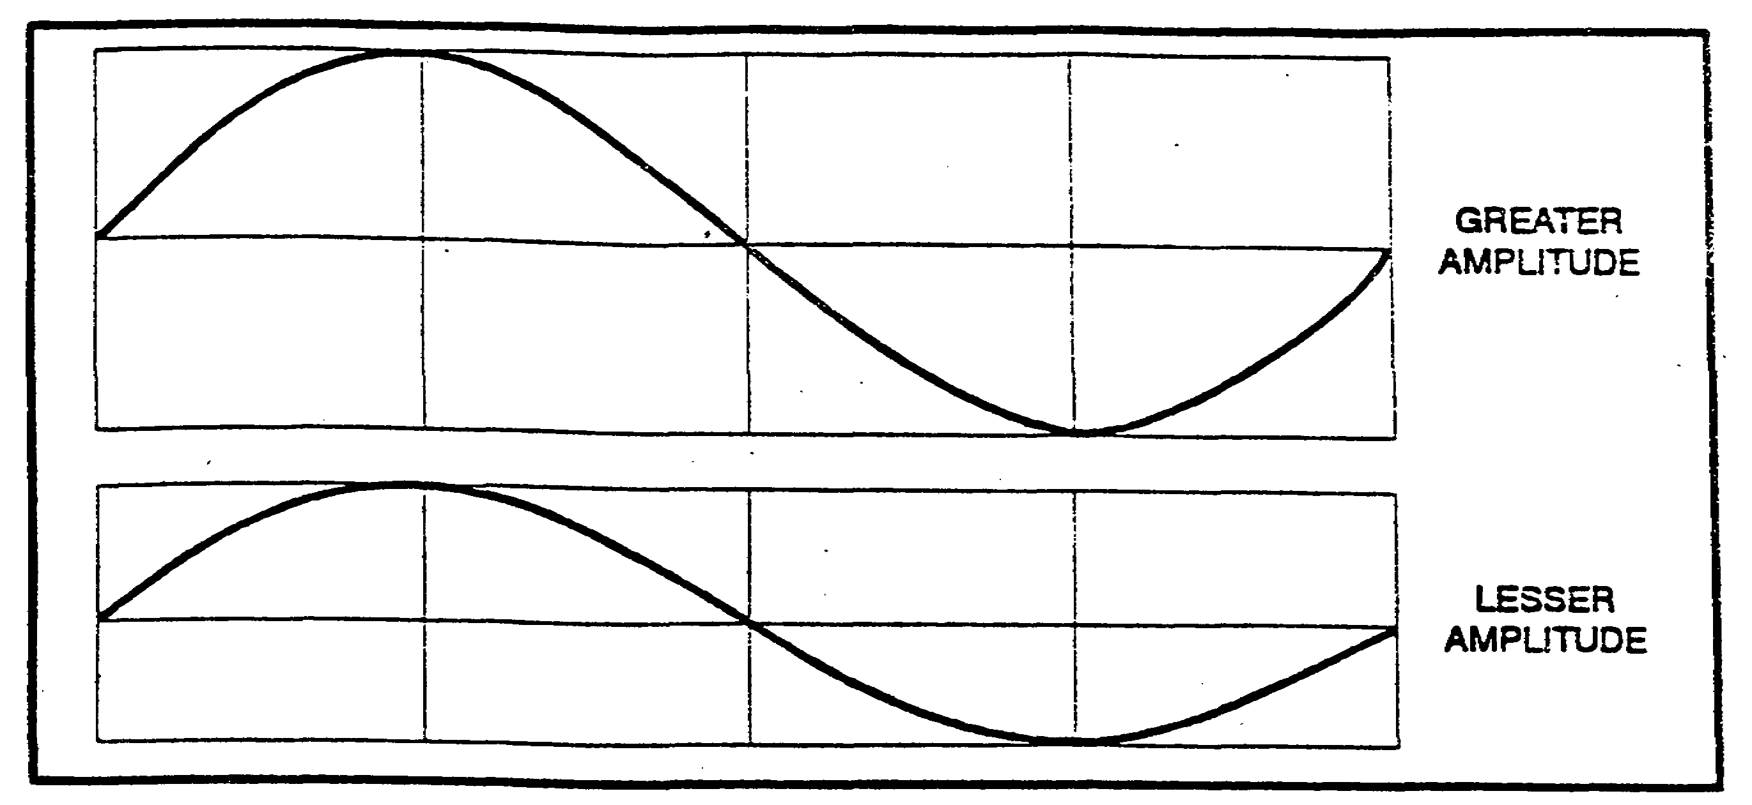

Figure 1-7. Amplitude difference.

(2) Period. How long does it take you to walk around the block? What if you crawled or ran, took your son's bicycle or your motorcycle? How long would it take then? The answer is measured in a period of time, from seconds to minutes to hours, to complete the 1 revolution or cycle around the block. For example, if the length around the block was 1000 yards, and you walked it in 10 minutes, then the period (the time to complete 1 cycle) was 10 minutes (fig. 1-8).

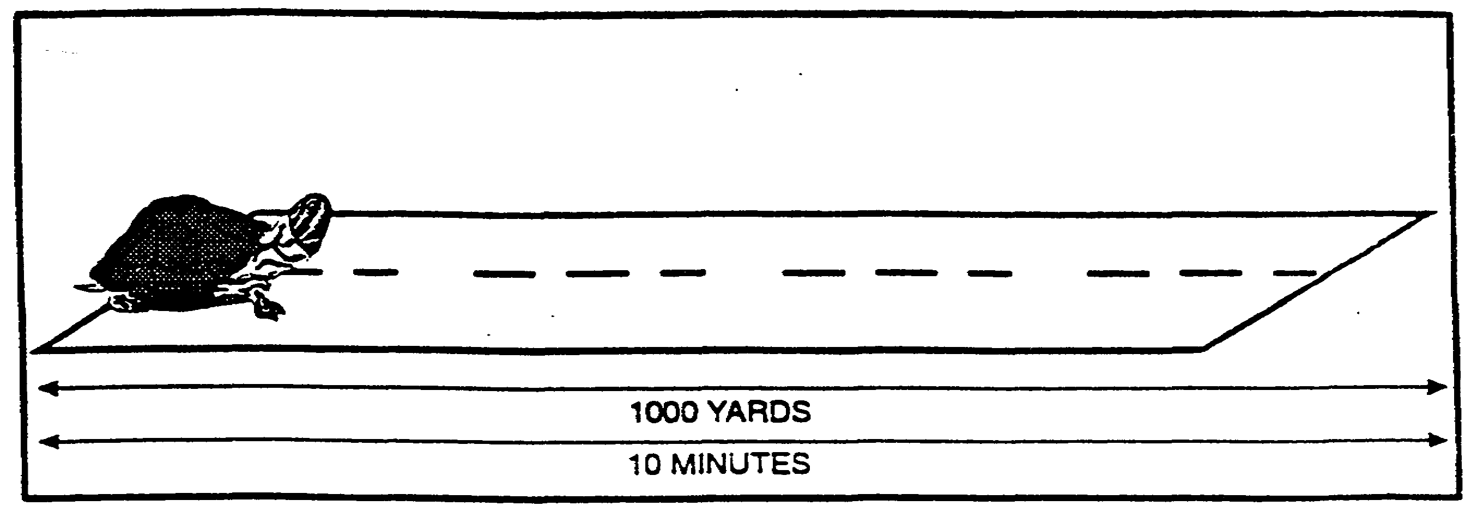
Figure 1-8. Long period.

If you had been running, using your bicycle, or motorcycle, your time would have been much less. Period then is a measure of the amount of time it takes to complete 1 cycle. In figure 1-9, the period to complete the cycle is 1 minute.

IT0300 1-6

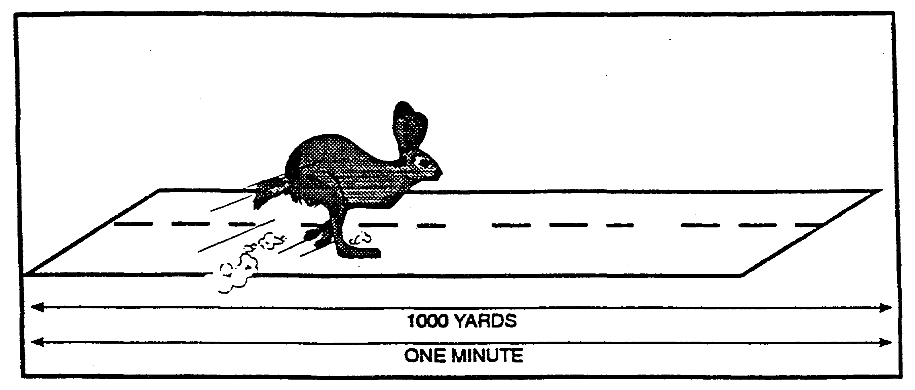

Figure 1-9. Short period.

(3) Frequency. Let us take the same 1000 yard block, but this time your son challenges you to run around it as many times as you can in 1 hour. Instead of facing the prospect of sheer exhaustion, why not run just 1 cycle around the block, check the time, and then announce the number you can do in an hour. How many cycles can you complete in 1 hour if it takes you 1 minute to complete 1 cycle? Frequency then is the number of cycles completed within a specific period of time.

(4) Period versus frequency. Notice the distinct relationship between period and frequency. Both have the factors of time and cycles, yet there is a difference in what they measure.

(a) Period measures the time per cycle.

TIME | = PERIOD
CYCLES | = PERIOD

(b) Frequency measures the cycles per time.

CYCLES | = FREQUENCY
TIME | = FREQUENCY

Both of these terms are useful in understanding and analyzing radio communications. If one quantity is known, then the other can, by simple arithmetic, be determined. Notice that the formulas for period and frequency are reciprocals, the inverted form of the other.

1-7 IT0300

(5) Cycles per second. For convenience and as a standard in radio communications, cycles per second is the measurement reference. That is the number of cycles that occur in 1 second...1000 cycles per second, 850 cycles per second, etc. From this you can determine the period. What is the period when you have a frequency of 1000 cycles per second?

FREQUENCY = | 1000 cycles
FREQUENCY = | 1 second

(INVERT TO FIND THE PERIOD)

PERIOD = | 1 second
PERIOD = | 1000 cycles

One one-thousandth of a second is the period or cycle length. If we divide a second into one thousand parts, the smallest part is called a millisecond. Therefore we can also say that the period or cycle length is 1 millisecond (fig. 1-10).

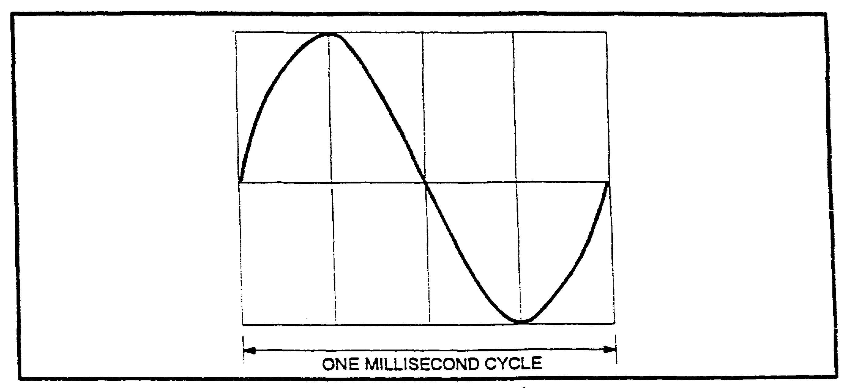

Figure 1-10. Cycle length.

(6) Phase. If frequency and period tell us how many and how long, then phase is a description of where a change or event occurs on the waveform. Phase is measured in terms of degrees. There are 360 degrees in a circle, and because a circle and a wave have similar components the wave also has 360 degrees. A degree is only a convenient way to locate points or positions on a circle or waveform.

IT0300 1-8

(7) Phase Changes. What is the location of 45 degrees in figure 1-11? The importance of locating a point where an event occurs on a waveform will become significant in future lessons on the study and analysis of complex waveforms, transmission systems, and methods of modulation.

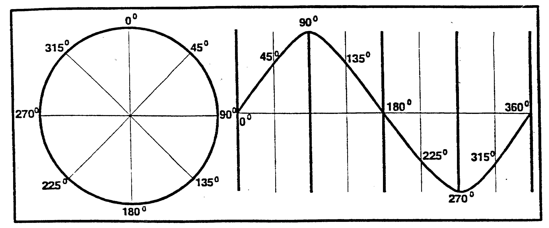

Figure 1-11. Degrees on circle and sine wave.

At this point, it is only necessary to understand that at particular points on the waveform, events can occur which will alter its shape. For example, if at point "A" in figure 1-12, we say that the waveform changes by 180 degrees, the resultant waveform would be the dashed line indicated.

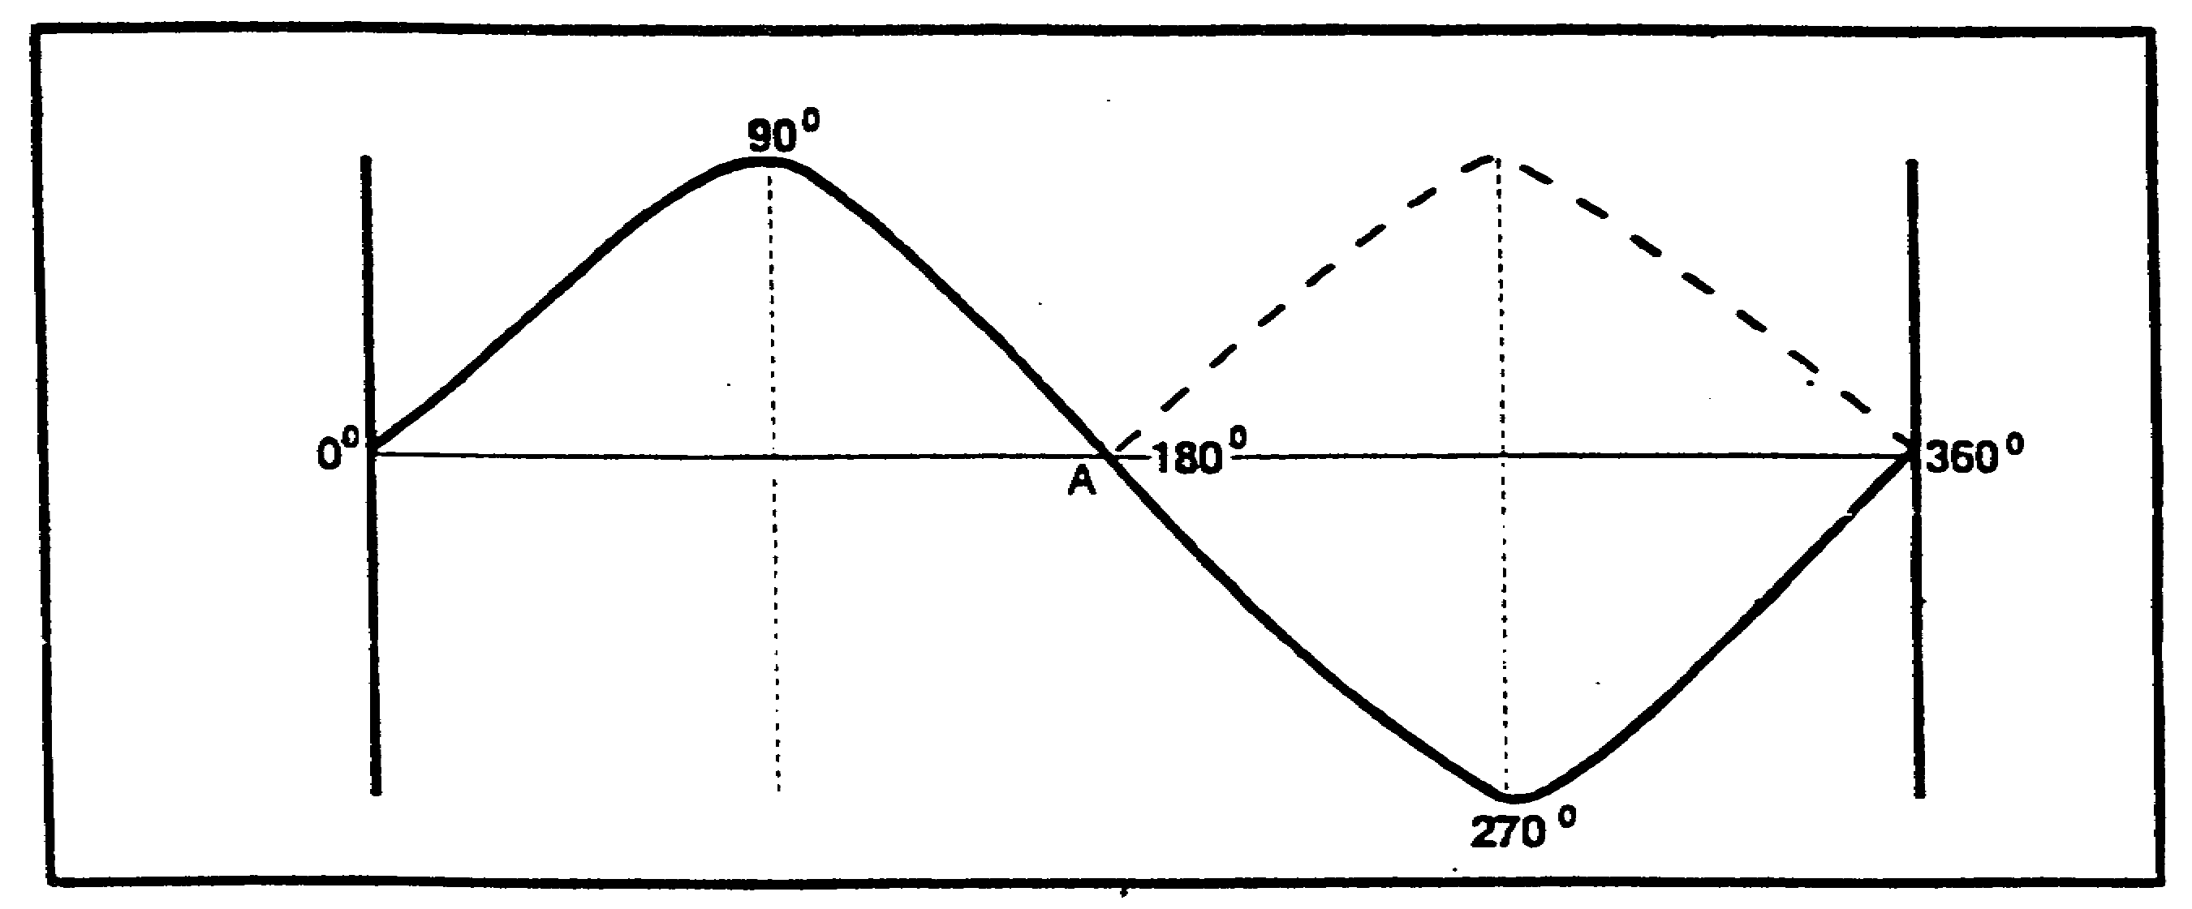

Figure 1-12. Change of phase.

A series of similar changes is shown in figure 1-13.

1-9 IT0300

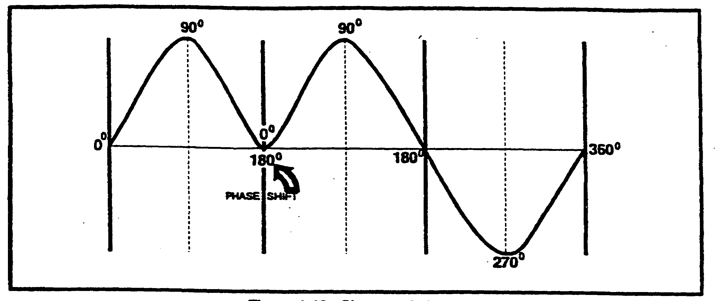

Figure 1-13. Change of phase.

Keep in mind, also that the point or location of the wave change can be anywhere and can occur any number of times.

(8) Wave addition. In later lessons terms such as wave mixing, modulation, heterodyning, harmonics, and intermodulation will become significant. These are terms for the complex actions that occur when two or more waves interact. A wave by itself transmits no intelligence or communicates no information, that information must be superimposed on it or added to it. This is called wave addition and is simply the arithmetic addition of two or more waveforms to produce an entirely new waveform. Figure 1-14 illustrates wave addition.

Wave "C" is the result of the arithmetic addition of waves A and B.

Point A = (0) +(0) = (0)
B = (-1) + (-2) = (-3)
C = (-2) + (0) = (-2)
D = (-1) + (+2) = (+1)
E = (0) + (0) = (0)
F = (+1) + (-2) = (-1)
G = (+2) + (0) = (+2)
H = (+1) +(+2) = (+3)
I = (0) +(0) = (0)

The limits to wave addition are only these imposed by the limits of man's imagination. Man's ability to extend the limits of his imagination has resulted in communication advances that now extend to the limits of the universe. The few characteristics covered in this lesson are the essence of radio communications.

IT0300 1-10

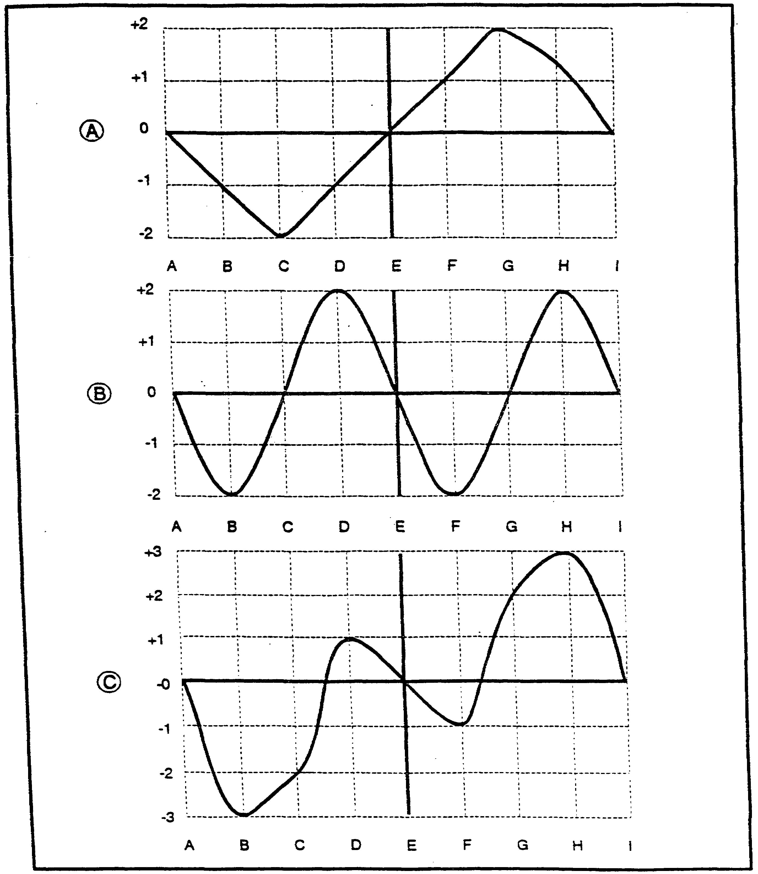

Figure 1-14. Wave addition.

1-11 IT0300

LESSON 1

PRACTICE EXERCISE

This PE is designed to check your comprehension of the material presented about Waves and Wave Characteristics. There is only one correct answer for each item. When you complete the exercise, check your answer key that follows. If you answer any item incorrectly, study again that part of the lesson which contains the portion involved.

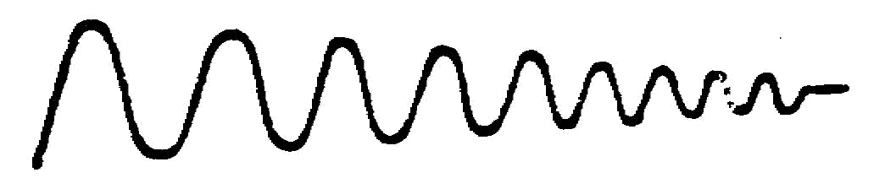
1. This waveform example is called?

A. Periodic.

B. Amplitude.

C. Damping.

D. Aperiodic.

2. A bouncing football is an example of what waveform?

A. Aperiodic.

B. Periodic.

C. Frequency.

D. Damping.

3. Which statement about a circle and a sine wave is most correct?

A. Both are round.

B. Both have 360 degrees.

C. Both are nonmathematically related.

D. Both are useful descriptions of a sine wave addition.

IT0300 1-12

4. If a circle were a path, and you took a repeated journey around it, this would be an explanation of cycles.

A. True.

B. False.

5. Amplitude is essentially a description of the force or energy applied to create a particular waveform.

A. True.

B. False.

6. Period is

A. the number of cycles completed in a specific period of time.

B. a reference point in time.

C. a reference point in space.

D. the amount of time it takes to complete 1 cycle.

7. Frequency is

A. time per cycle.

B. a reference in distance traveled.

C. cycles per period of time.

D. calculated with the same formula as period.

8. | TIME | = is the formula for
8. | CYCLE | = is the formula for

A. Amplitude.

B. Period.

C. Phase.

D. Frequency.

1-13 IT0300

9. What is the period in milliseconds, when you have a frequency of 500 cycles per second?

A. 1.

B. 2.

C. 3.

D. 4.

10. One one-thousandths of a second is called a

A. Millisecond.

B. MPS.

C. RMS.

D. Nanosecond.

11. If frequency and period tell us how many and how long, then phase tells us

A. How.

B. Why.

C. What.

D. Where.

12. Wave mixing, as described in this lesson, is the complex algebraic manipulation of the geometric components of a sine wave.

A. True.

B. False.

13. A periodic wave can be described as

A. a wave in which the peaks and troughs occur at irregular intervals.

B. the damping effect of a bouncing basketball.

C. the repetitive occurrence of the same peaks and troughs at fixed intervals of time.

D. the effect of a bouncing football.

IT0300 1-14

14.

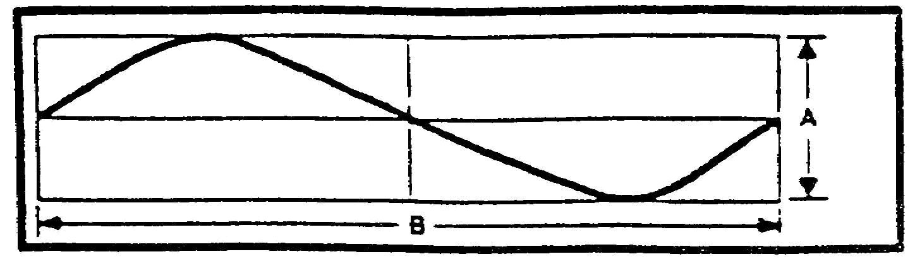

A. area and B is the volume.

B. period and B is the frequency.

C. amplitude and B is the period.

D. amplitude and B is the phase.

15. Add the following sets: (- 1) + (- 3) =
(- 3) + (+2) =
(+2) + (+1) =
(+3) + (- 3) =

A. (+4), (- 5), (+3), (- 6).

B. ( -4), (- 1), (+3), (- 3).

C. (- 4), (+5), (+3), (0).

D. (- 4), (- 1), (+3), (0).

1-15 IT0300

LESSON 1

PRACTICE EXERCISE

ANSWER KEY AND FEEDBACK

Item Correct Answer and feedback

1. C. Damping (page 1-2)

2. A. Aperiodic (page 1-3)

3. B. Both have 360 degrees (page 1-4)

4. A. True (page 1-5)

5. A. True (page 1-5)

6. D. the amount of time it takes to complete 1 cycle (page 1-6)

7. C. cycles per period of time (page 1-7)

8. B. period (page 1-7)

9. B. 2 (page 1-8)

10. A. millisecond (page 1-8)

11. D. where (page 1-8)

12. B. False (page 1-10)

13. C. the repetitive occurrence of the same peaks and troughs at fixed intervals of time. (page 1-2)

14. C. amplitude and B is the period (page 1-6)

15. D. (-4), (-1), (+3), (0) (page 1-10)

IT0300 1-16

LESSON 2

RADIO WAVES AND PROPAGATION

CRITICAL TASK: 301-98K-1302

OVERVIEW

LESSON DESCRIPTION:

In this lesson you will learn the basic elements of radio communications, simple communications systems, radio waves, frequency classification methods, wave propagation, components of the atmosphere, and paths of radio waves and the characteristics of these paths.

TERMINAL LEARNING OBJECTIVE:

TASK: Identify different types of communication systems and radio wave propagation.

CONDITION: You will use the information provided in this subcourse.

STANDARD: To demonstrate competency of this task, you must achieve a minimum of 70 percent on the subcourse examination.

REFERENCES: The material contained in this lesson was derived from the following publications: Elements of Signal Theory (EOST), Methods of Modulation (MOM), and Communications -Electronic Fundamentals: Transmission Lines, Wave Propagation, and Antennas (FM 11-64).

INTRODUCTION

1. One of the most astounding characteristic of modern man is his capability to communicate verbally. Science now appears to be validating the fact that all forms of life can in one way or another communicate; but only man has the capability to convey both verbal and non-verbal information, to exchange thoughts and opinions, either face to face or over great distances. The advances in science and technology continually add new dimensions to this communicative ability of modern man and have freed him from the limits of face to face communications. Now space vehicles traveling literally millions of miles from earth, control and communicate data for further advances of modern man. The linking element, the connector from the point where information originates to the point where the information is received is the electromagnetic (radio) wave. The radio wave is the essential link in all long-distance communications systems.

a. Communications system. Any system which transfers information from one point to another is a communications system. Two people talking softly and sweetly, or two rowdies in violent heated dispute are communications systems. Reading the daily newspaper -information originated by a reporter, put into printed form, and read casually at the breakfast table, or hurriedly on the subway to work is also a communications system. Tin-can telephone systems of boy scouts to the highly complex satellite telephone relay systems; commanders posting orders on bulletin boards to immediate combat orders in tactical situations -all are communications systems. There are basically four elements to any communications system:

2-1 IT0300

(1) A transmitter.

(2) A receiver.

(3) Information or data to be transmitted.

(4) A means or an agent to carry the information or data.

b. Radio Communications System. A radio communications system (fig. 2-1) consists of a microphone, telegraphers key, or similar device that generates Audio Frequency (AF) energy; a transmitter that converts the AF energy into Radio Frequency (RF) energy by wave addition or wave mixing; a transmitting antenna that radiates the RF energy or radio waves; a receiving antenna that receives the radio waves; a receiver that reconverts the received radio waves into AF waves; and a loudspeaker, headset, or teletypewriter to provide intelligible information. Without radio waves the radio communications system would not exist.

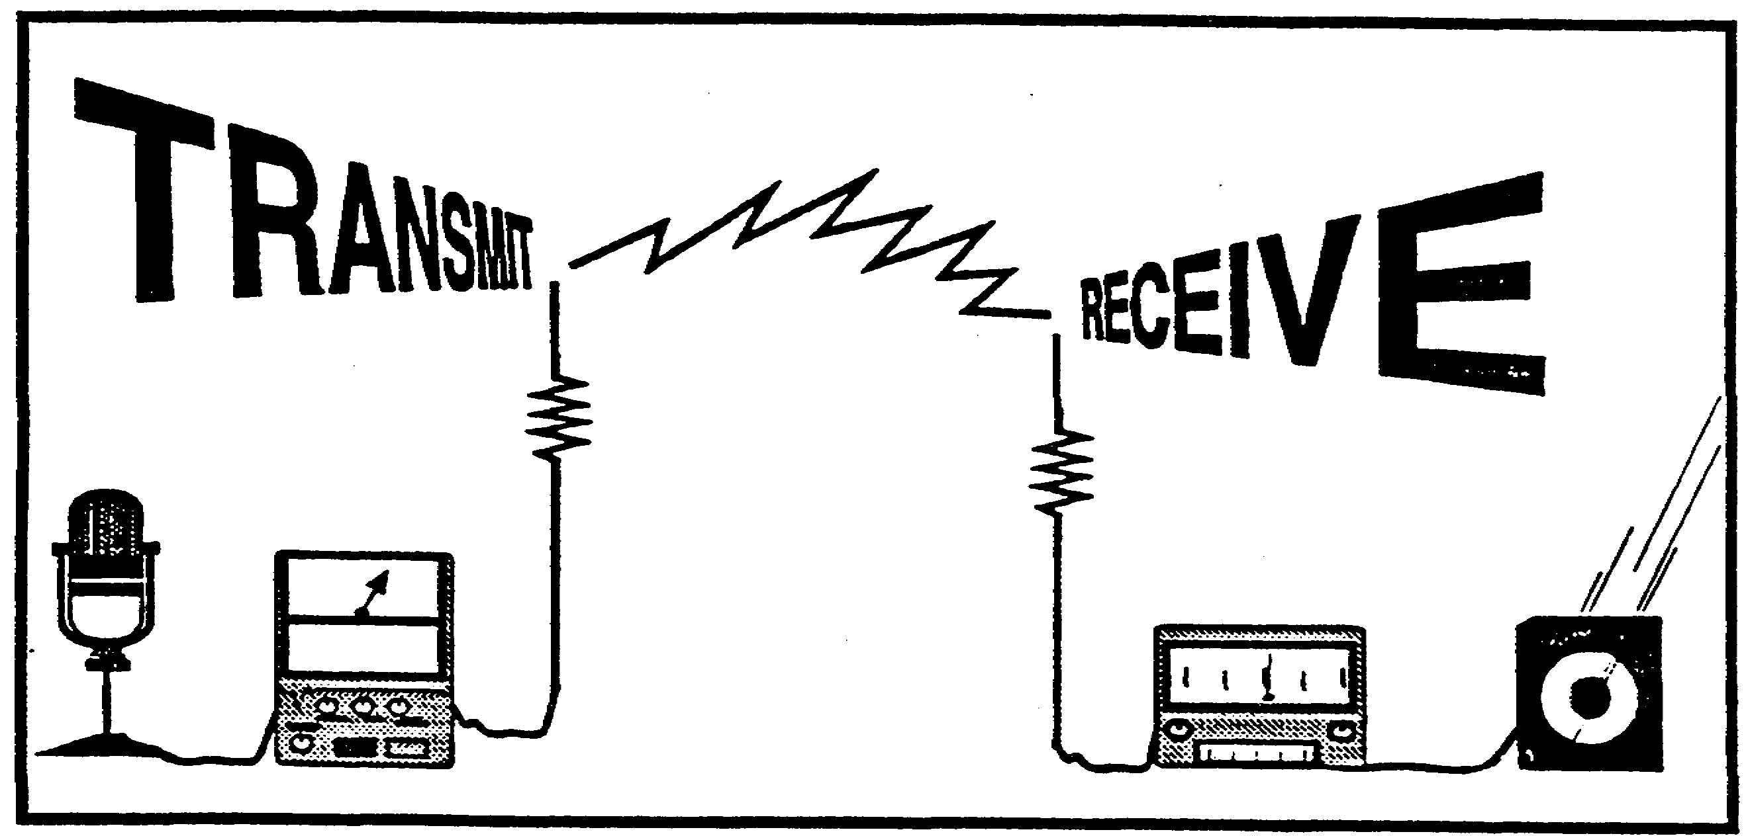

Figure 2-1. RADIO WAVES

2. Quite simply, a radio wave is an electromagnetic wave traveling through space at the speed of light, 186,000 miles per second or 300,000 kilometers per second. From this you can see that it would take approximately 2 seconds for these waves to reach the moon; the moon being 238,857 miles from the earth. The generation of radio waves will be covered in future lessons on the fundamentals of radio communications.

a. Audio Frequency. Without aid the distance the human voice can travel is very limited. Go to a football field with a friend and both of you stand together at one end of the field. Speak in a normal tone of voice; then at increments of ten paces at a time separate, but continuing to speak in a normal tone of voice. At what point does the speaking become impossible to understand? At what point does it become impossible to hear? Now raise the tone and volume of your voice, still continuing to separate at increments of ten paces. Now at what point does the information become unintelligible? Can

IT0300 2-2

you shout loud enough for your voice to carry and the information to be understood when you are both separated by the complete length of the football field? In order to extend the distance, it is necessary to convert sound waves, or waves that vibrate at an audio frequency, into electromagnetic waves. This conversion is accomplished in a radio transmitter. The frequency at which the radio wave vibrates effects the distance the radio wave will travel. The frequency of the radio wave is the number of complete cycles that occur in 1 second. The longer the time of 1 cycle, the longer the wavelength and the lower the frequency, and the farther it will travel in distance.

The shorter the time of 1 cycle, the shorter the period or wavelength and the higher the frequency, the shorter will be its distance of travel. The wavelength or cycle length may be measured from the start of one wave to the start of the next wave, or from any point on one wave to the same point on the next wave. In figure 2-2 it is easy to see that there are 1, 2, and 4 cycles occurring respectively within the time frame of 1 second.

2-3 IT0300

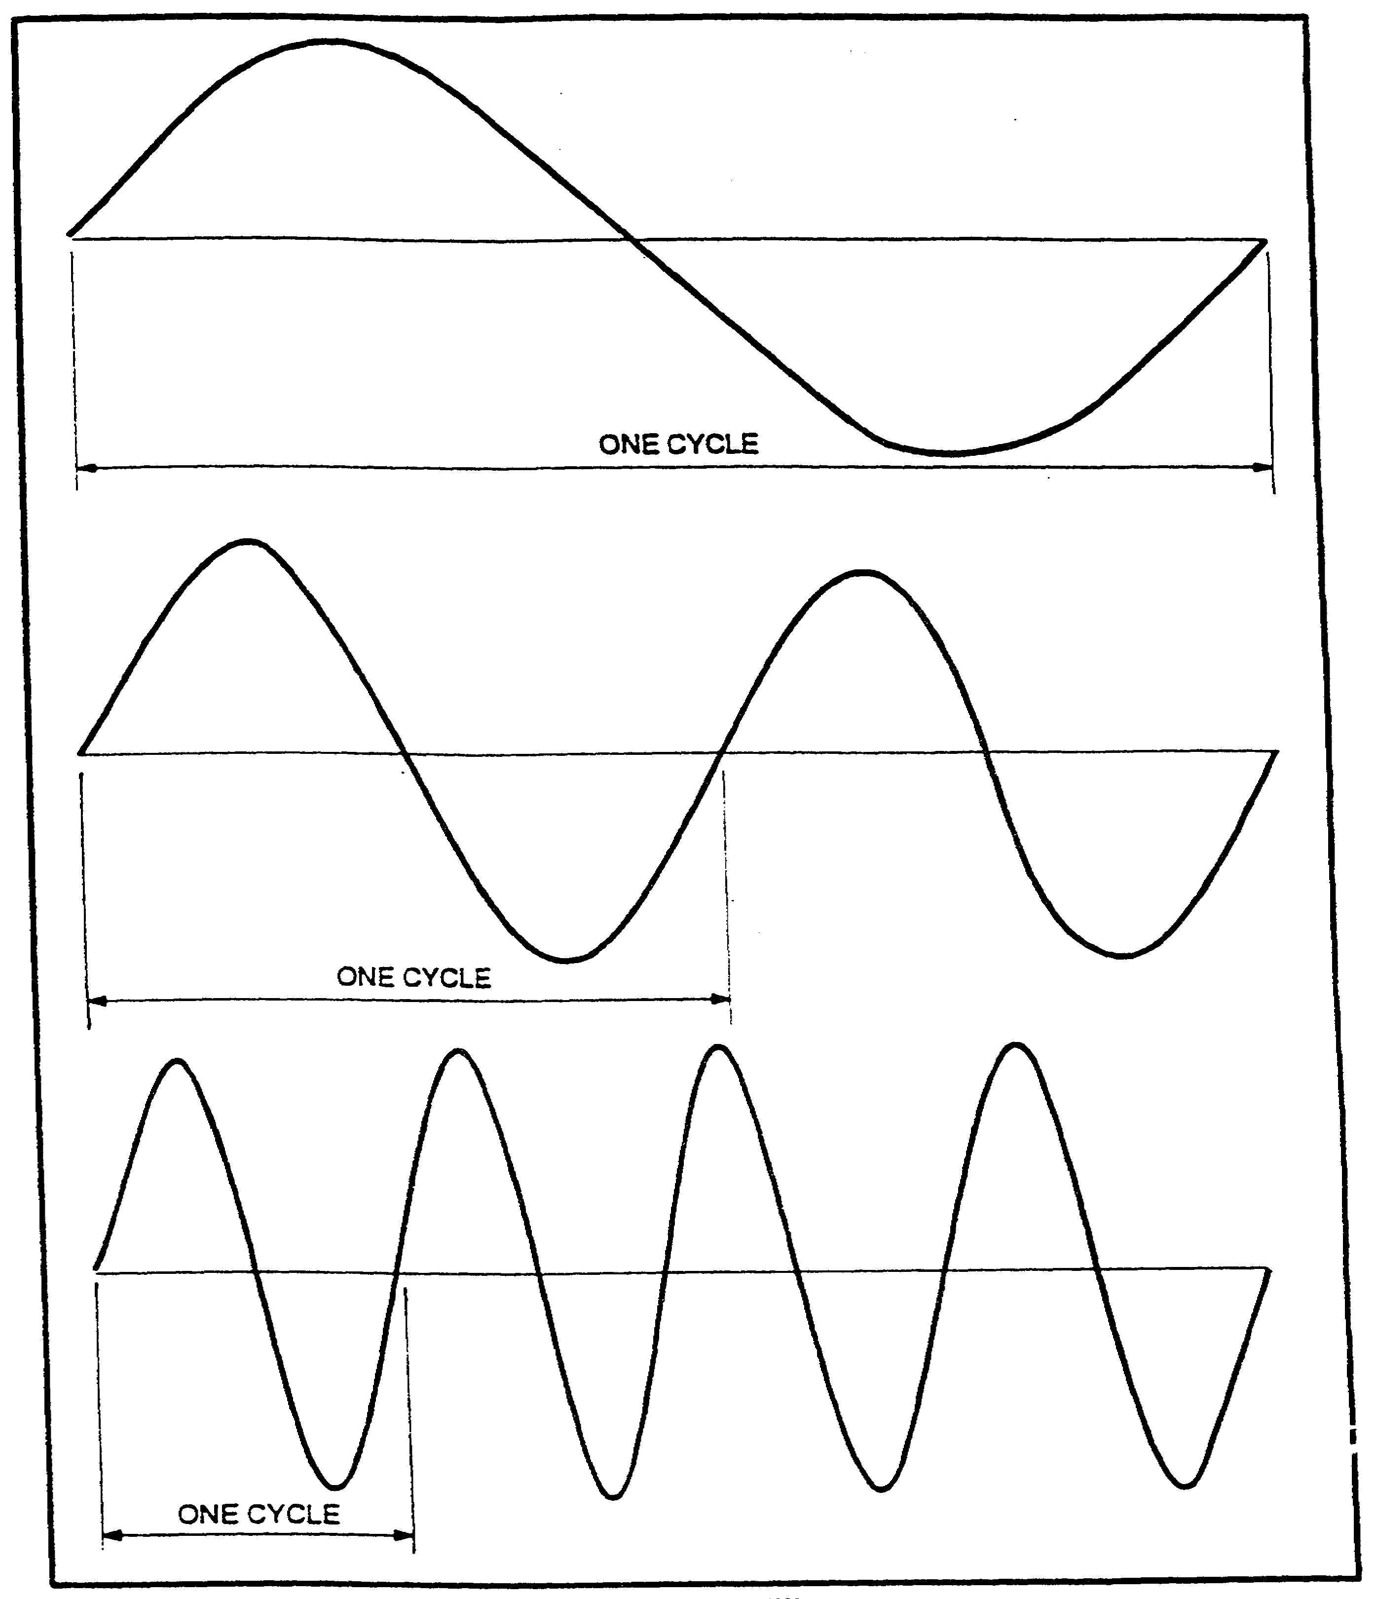

Figure 2-2. Frequency difference.

b. Frequency. Radio waves are classified according to their frequency; that is, the number of cycles that occur within 1 second. In radio communications the term Hertz (Hz) is equivalent to the term cycle.

IT0300 2-4
1,000 Hz = 1 kHz = 1 Kilohertz
1,000,000 Hz = 1 MHz = 1 Megahertz
1,000,000,000 Hz = 1 GHz = 1 Gigahertz
1,000,000,000,000 Hz = 1 THz = 1 Terahertz

The range of the human voice or audio frequency is 20 Hz to 20,000 Hz. The radio frequency range extends from 10 kHz (10,000 Hz) to 300,000 MHz.

c. Frequency Classification Methods. Every radio transmission uses some portion of the radio frequency spectrum between 10 kHz to 300,000 MHz. To eliminate confusion and facilitate international understanding the majority of the countries of the world have joined in establishing standard classification systems. These methods are by frequency (as described in paragraph b above), frequency bands and wavelengths.

(1) Frequency Bands.

Very Low Frequency (VLF) 3 kHz to 30 kHz
Low Frequency (LF) 30 kHz to 300 kHz
Medium Frequency (MF) 300 kHz to 3,000 kHz
High Frequency (HF) 3 MHz to 30 MHz
Very High Frequency (VHF) 30 MHz to 300 MHz
Ultra High Frequency (UHF) 300 MHz to 3,000 MHz
Super High Frequency (SHF) 3 GHz to 30 GHz
Extremely High Frequency (EHF) 30 GHz to 300 GHz

(2) Wavelength. This is the distance between corresponding points on two consecutive waveforms and is measured in meters. It may be found by the following formula:

300,000,000
------------= wavelength
frequency (Hz)

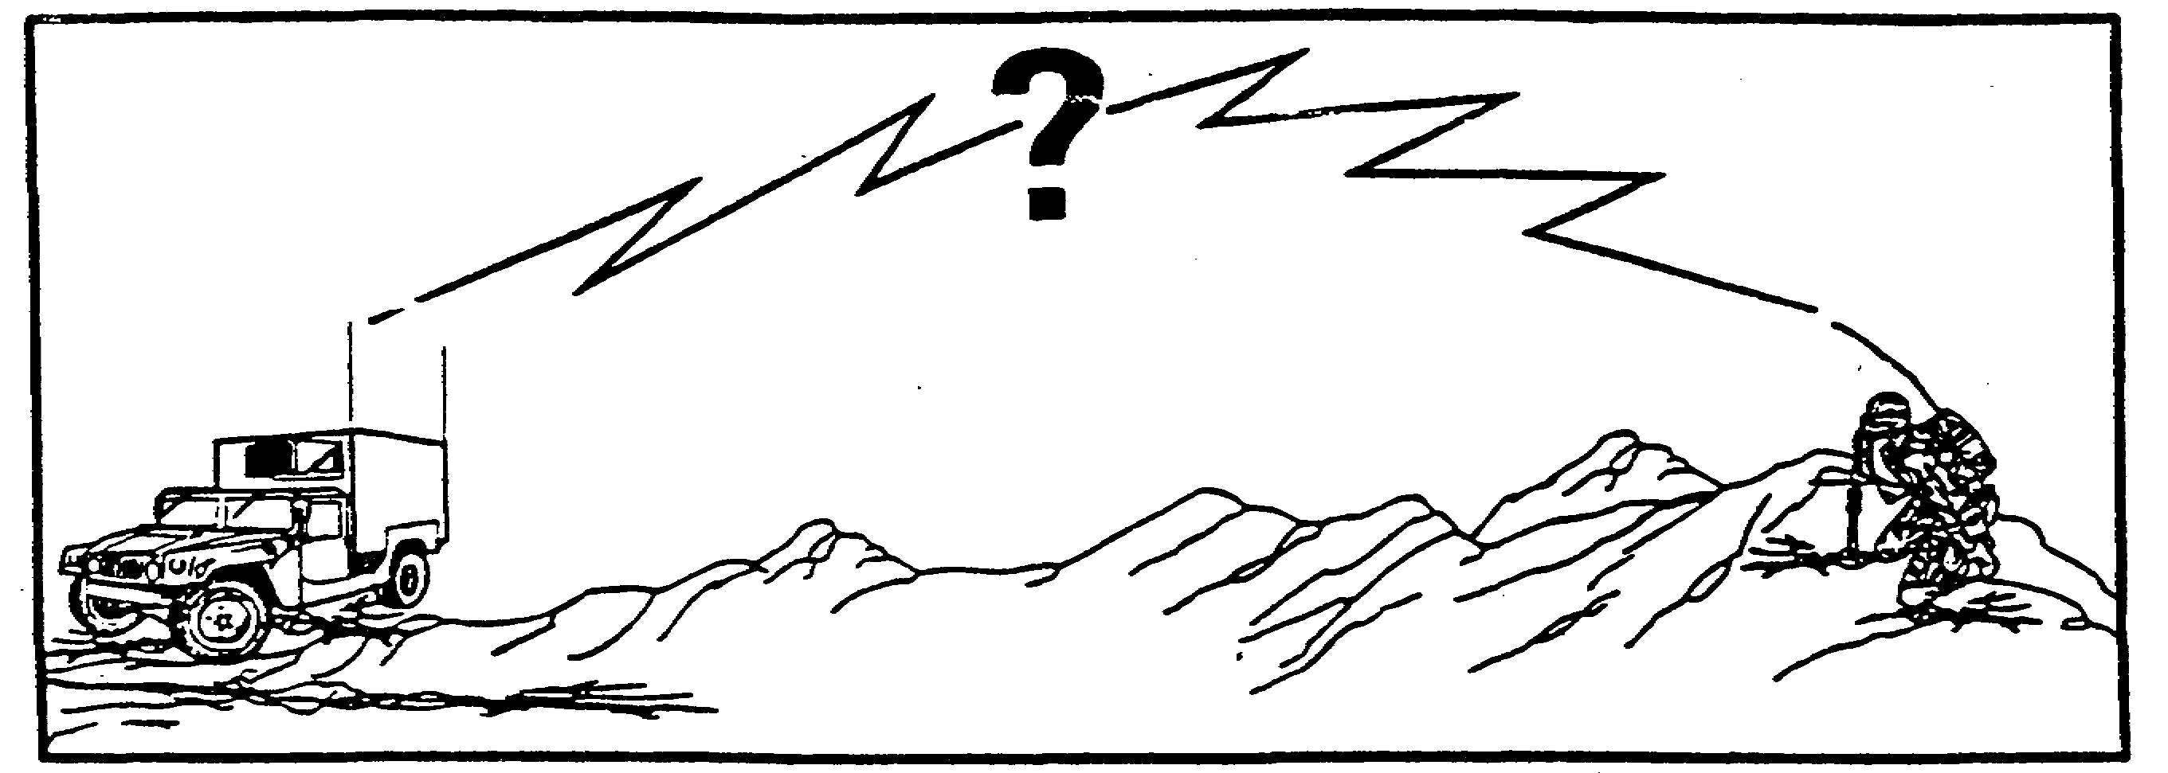

Figure 2-3. What effects wave propagation?

Wave propagation deals with the properties and the nature of the atmosphere through which radio waves must travel from the transmitting antenna to the receiving antenna (fig. 2-3).

2-5 IT0300
Successful communications between two points depends upon four properties - POWER - DISTANCE - SENSITIVITY - CONDUCTIVITY.

The power of the transmitter.
The distance between the transmitter and the receiver.
The sensitivity of the receiver.
The conductivity of the earth and the earth's atmosphere.

The study of the wave propagation is primarily concerned with conductivity (fig. 2-4). The characteristic or property which we call "conductivity" may be defined as that attribute or quality which serves to aid or hinder the transmission or movement of a substance or impulse from one point to another point.

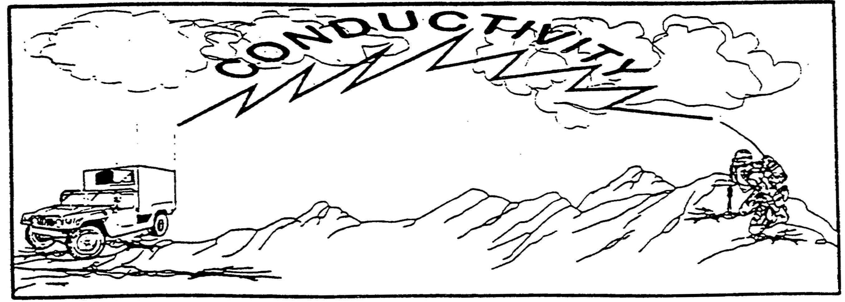

Figure 2-4. Property of wave propagation.

3. Quite simply we mean a pipe that allows the transmission of water from a reservoir to the homes in a community has a property called conductivity; that the gas line from your automobile gas. tank to your carburetor has the property of conductivity; that the power cord from the wall outlet to the back of your television set has the property of conductivity; the atmosphere which

IT0300 2-6

us to carry on normal conversations across the room has conductivity; a tree splitting apart from the force of lightning has conductivity. The earth, the atmosphere, all animate and inanimate things upon, over, and under the earth have this property we call conductivity in one degree or another. The study of radio wave propagation is primarily concerned with the conductivity of the earth and its surrounding atmosphere. The earth and the surrounding atmosphere are not uniform, but are constantly subject to change...temperature, weather, pressure, and atmospheric changes due to altitude and geographic location, and even changes related to the time of day. These changes greatly influence the passage or transmission of electromagnetic (radio) waves. A knowledge of the atmosphere's composition is required for future lessons on antennas, communications paths, and understanding or predicting the relative reliability of radio communications systems.

a. The Atmosphere. The atmosphere is separated, generally, into three portions -TROPOSPHERE -STRATOSPHERE -IONOSPHERE (fig. 2-5). The ionosphere is further divided into sublayers. (A study of these sublayers will be covered in a future lesson on antennas.)

(1) Troposphere. This is the inner layer of the atmosphere which varies in height from 6 to about 12 miles above the surface of the earth.

(2) Stratosphere. This is that part of the atmosphere that extends from the outer limits of the troposphere to about 30 miles above the surface of the earth.

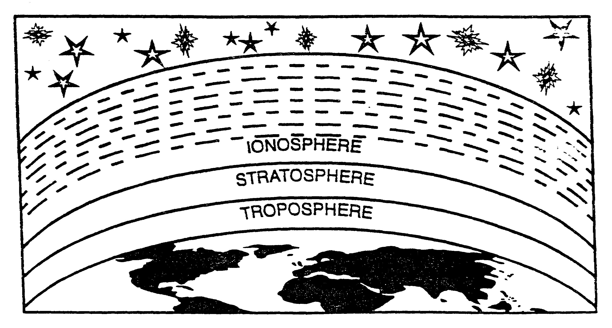

Figure 2-5. Atmospheric layers.

2-7 IT0300

(3) Ionosphere. This is that part of the earth's atmosphere which extends from the outer limits of the stratosphere to about 250 miles above the earth's surface. This part of the atmosphere consist of several ionized layers. Ionization is the electrical charging of the atoms take on either a positive or negative charge. Our concern is the effect this ionized layer has upon the transmission of radio waves.

b. Radio Wave Paths. There are two principal paths or routes by which radio waves can travel directly or indirectly from the transmitter to the receiver -GROUNDWAVES and SKYWAVES.

(1) Groundwaves are those radio waves which tend to follow the curvature of the earth when they travel from the transmitter to the receiver. These waves are affected by the electrical characteristics of the earth, which cause the bending, or diffraction, of radio waves around the curvature of the earth. Defraction is an important term to remember. To repeat, it is the bending of a radio wave, a light wave, or a sound wave around the surface, edge, or curvature of a solid object. For example when you speak to another person in another room through a closed door, diffraction is what causes that sound to be heard or to be transmitted; a room with all the shades pulled down still is not totally dark because diffraction allows the rays of the sun to bend around the shade to allow light to enter. The electrical characteristics of the earth vary in different locations, but do remain relatively stable from season to season. Short distance AM transmissions and all UHF and upper VHF radio transmissions are by means of groundwaves. There are three principal types of groundwaves -SURFACE -DIRECT -REFLECTED (fig. 2-6).

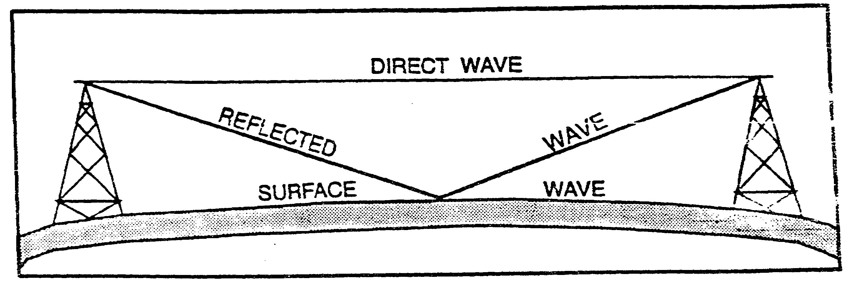

Figure 2-6. Groundwaves.

(a) The direct wave is a direct line-of-sight from the transmitting antenna to the receiving antenna.

(b) The reflected wave reaches the receiving antenna by being reflected from the surface of the earth.

(c) The surface wave, as the title implies, follows the curvature of the earth's surface from the transmitting antenna to the receiving antenna.

IT0300 2-8

(2) Skywave paths are highly dependent upon the conditions which exist within the ionosphere. Because the ionosphere is in a constant state of flux, the skywave paths are variable. There are two categories of this variation predictable and irregular. This lesson will not cover the complexities of the causes for the variations except to say that the movement of the earth around the sun and irregular variations in the sun's activities contribute to these ionospheric changes.

c. Propagation. Propagation is essentially the action of extending the distance traveled by radio waves by employing power, location, and sensitivity of radio equipment, combined with the natural, variable, and conductive characteristics of the earth and the atmosphere surrounding it. Radio waves may travel from the transmitter to the receiver directly or indirectly, by being bounced, bent, or curved. In addition to defraction, there are two more terms which refer to the bouncing, bending, or curving of radio waves -REFLECTION and REFRACTION.

(1) Reflection. This refers to the bouncing of radio waves from the ionosphere or from the surface of the earth (fig. 2-7). A ball rolling along the pool table will hit the cushion and bounce off at the same angle at which it strikes the cushion. This is the same characteristic displayed by a radio wave as it is reflected from the ionosphere or the surface or the earth. A point to remember is that at each point of reflection, the radio wave reverses its phase or polarity.

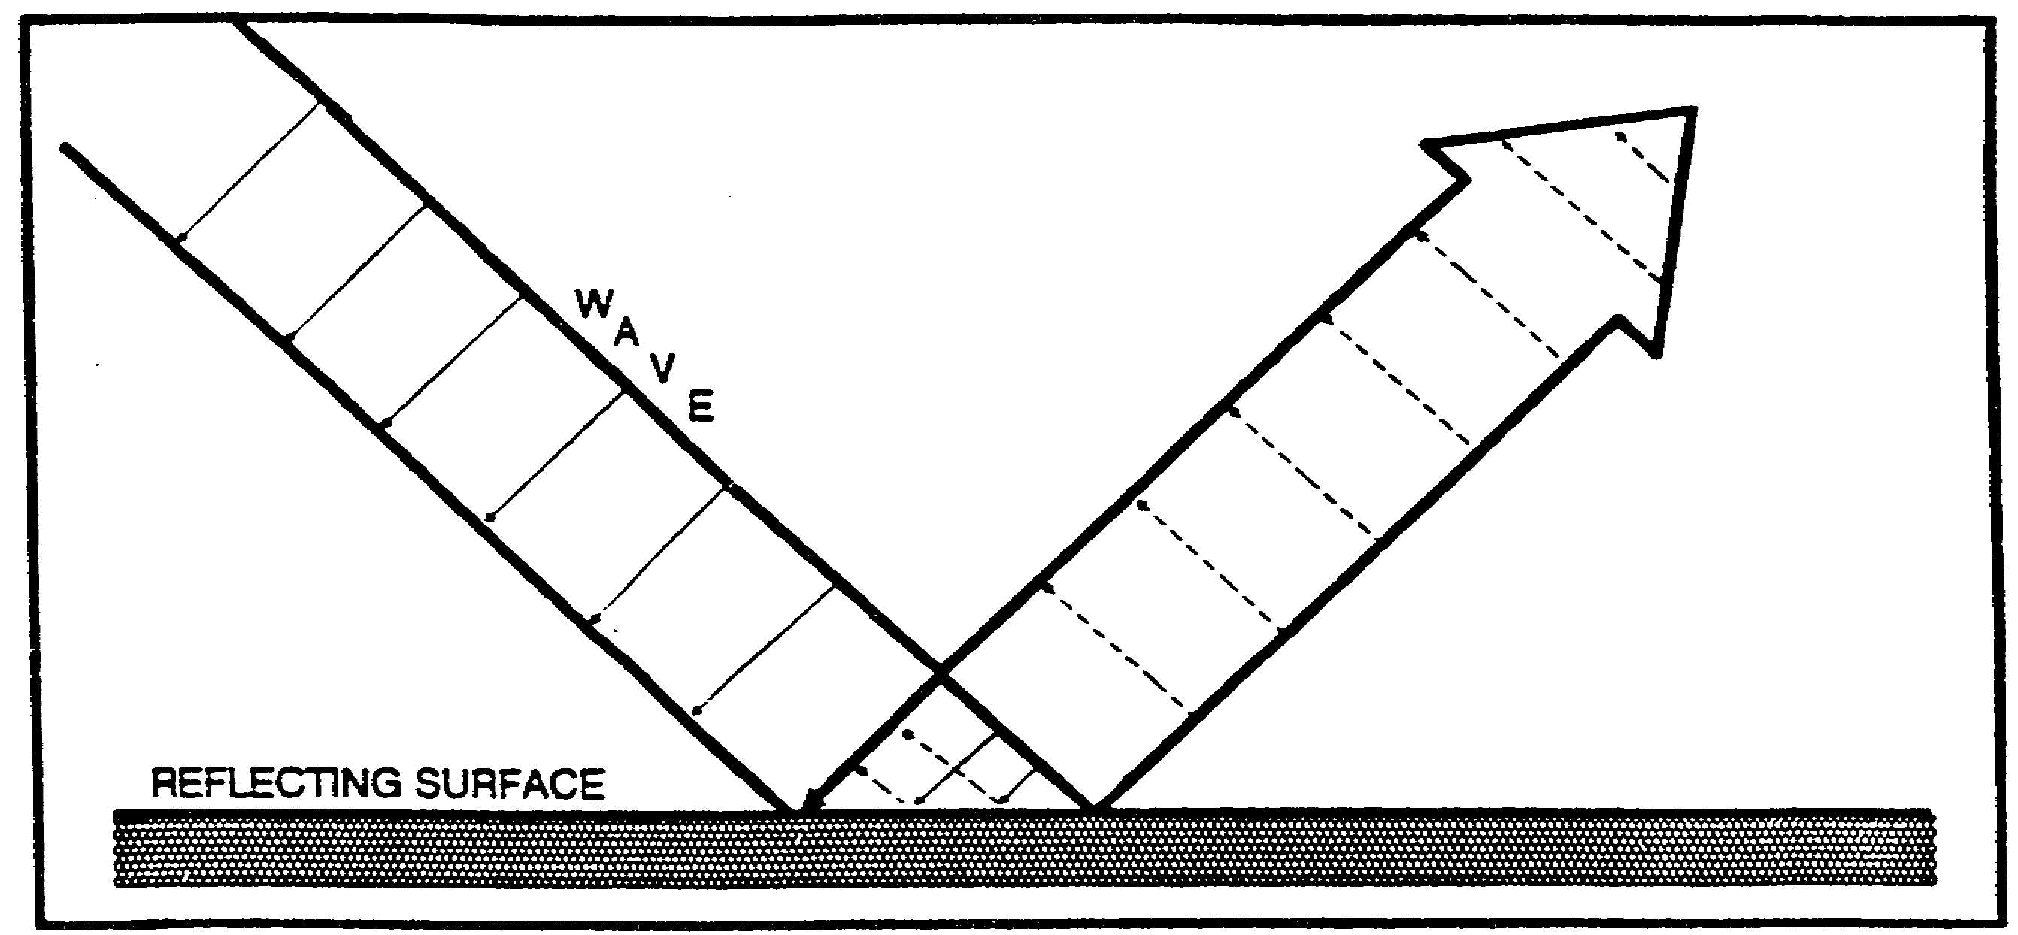

Figure 2-7. Wave reflection

(2) Refraction. Like diffraction, refraction is the bending of a radio wave (fig. 2-8). Where diffraction is the bending as the wave passes near the edge or surface of a solid object, refraction is the bending that results when the radio wave passes through portions of the atmosphere. For example, if you dropped a spoon into a glass of water, you would notice that it appeared to be bent. This is the refraction of light waves. The phase or the polarity of the waves remain the same, but the wave velocity or speed decreases in water accounting for the bending of the wave.

2-9 IT0300

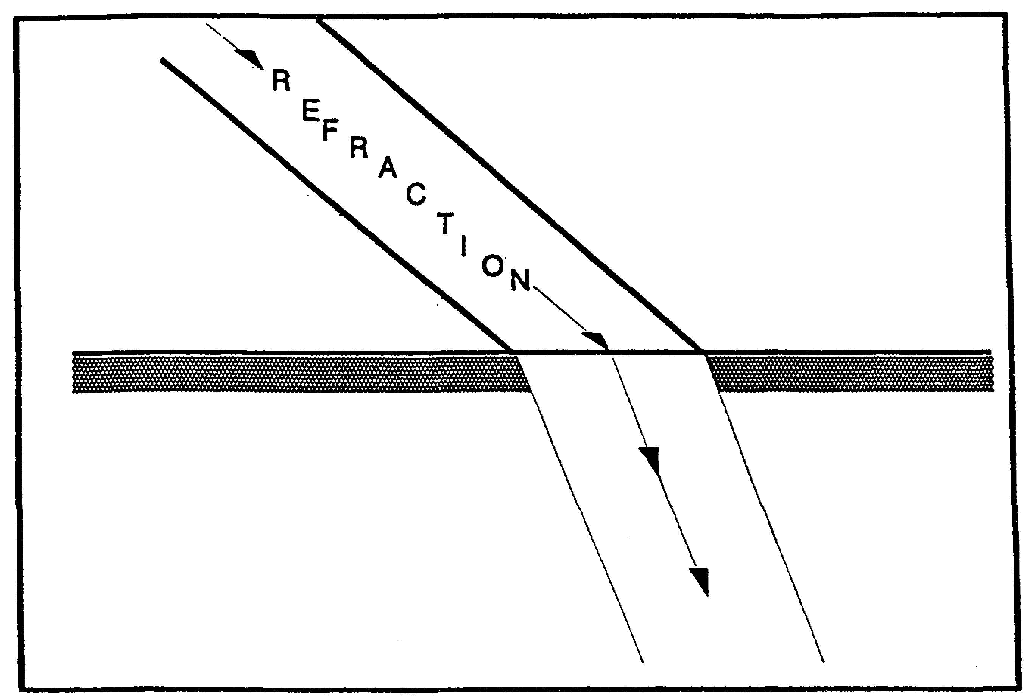

Figure 2-8. Wave refraction.
4. Summary. The intent of this short lesson was to introduce you to the very basics and vocabulary associated with radio waves and wave propagation. This lesson pointed out that the elements of a communications system are the transmitter, the receiver, information to be transmitted, and a means or agent to carry the information. We have discovered, that radio .waves were the means or agent. We have learned, that radio waves are identified by their frequency, frequency band, or wavelength. We have learned that the earth's atmosphere is divided into different parts, the troposphere, the stratosphere, and the ionosphere. We discussed skywaves and groundwaves as the principal types of radio waves. As we completed the lesson we learned that many things effect the propagation of skywaves and radio waves. Although these few paragraphs are very elementary, their complete understanding will be instrumental to understanding further lessons.

IT0300 2-10

LESSON 2

PRACTICE EXERCISE

This PE is designed to check your comprehension of the material presented about Radio Waves and Propagation. There is only one correct answer for each item. When you complete the exercise, check your answers with the answer key that follows. If you answer any item incorrectly, study again that part of the lesson which contains the portion involved.

1. What is not one of the elements of any communications system?

A. A transmitter.
B. A receiver.
C. Information or data to transmit.
D. Electromagnetic current.

2. An electromagnetic wave travels at the speed of light or

A. 186,000 kilometers per hour.
B. 186,000 miles per hour.
C. 300,000 kilometers per second.
D. 300,000 miles per second.

3. One wavelength is equal to 1

A. cycle.
B. meter.
C. yard.
D. second.

4. The frequency of a radio wave is the number of complete cycles that occur in 1 second.

A. True.
B. False.

5. The shorter the time of one cycle, the shorter the wavelength, and the lower the frequency.

A. True.
B. False.

2-11 IT0300

6. A wavelength may be measured

A. from the start of one wave to the start of the next wave.
B. from a point on one wave to the same point on the following wave.
C. from the end of one wave to end of the next wave.
D. by all of the above.

7. The range of the human voice is

A. 20 feet to 20,000 feet per second.
B. 10 kHz to 300,000 MHz.
C. 20 Hz to 20 kHz.
D. 10,000 Hz to 20,000 kHz.

8. One million Hertz is equal to

A. 1 kHz.
B. 1 MHz.
C. 1 GHz.
D. 1 THz.

9. The High Frequency (HF) band is

A. 300 MHz to 3,000 MHz.
B. 3 kHz to 30 kHz.
C. 3 MHz to 30 MHz.
D. 30,000 kHz to 300 THz.

10. The atmosphere is subdivided into

A. the troposphere.
B. the stratosphere.
C. the ionosphere.
D. all the above.

11. Successful communications between two points depends upon

A. power, distance, sensitivity, and conductivity.
B. height, weight, length, and strength.
C. climate, location, and elevation.
D. rotation of the earth, the sun, and the moon as they create opposing magnetic fields.

IT0300 2-12

12. Two principal paths by which radio waves can travel are

A. through air and through solids.
B. groundwaves and skywaves.
C. direct waves and reflected waves.
D. surface waves and submarine waves.

13. The ionosphere is the portion of the earth's atmosphere which extends from 250 miles to approximately 3,000 miles above the earth's surface.

A. True.
B. False.

14. A reflected wave

A. changes polarity or phase when it is reflected from a reflecting surface.
B. does not change polarity.
C. travels directly from point to point.
D. does not reflect off the ionosphere.

15. Two categories of skywave variation are

A. regular and irregular.
B. direct and indirect.
C. predictable and irregular.
D. tropospheric and atmospheric.

16. The bending effect observed when a spoon is dropped in a glass of water is called

A. differentiation.
B. diffraction.
C. reflection.
D. refraction.

17. A receiver converts intercepted RF waves into AF waves.

A. True.
B. False.

2-13 IT0300

18. The frequency at which the electromagnetic wave vibrates does not affect the distance the radio wave will travel.

A. True.
B. False.

19. The term used for measuring the number of cycles occurring in 1 second is

A. circle.
B. hertz.
C. period.
D. times.

20. Which of the following is not a frequency band?

A. HF.
B. MF.
C. EHF.
D. EF.

IT0300 2-14

LESSON 2

PRACTICE EXERCISE

ANSWER KEY AND FEEDBACK

Item Correct Answer and feedback

1. D. Electromagnetic current (page 2-2)

2. C. 300,000 kilometers per second (page 2-2)

3. A. Cycle (page 2-3)

4. A. True (page 2-3)

5. B. False (page 2-3)

6. D. by all of the above (page 2-3)

7. C. 20 Hz to 20 kHz (page 2-5)

8. B. 1 MHz (page 2-5)

9. C. 3 Mhz to 30 Mhz (page 2-5)

10. D. all the above (page 2-7)

11. A. power, distance, sensitivity, and conductivity (page 2-6)

12. B. groundwaves and skywaves (page 2-8)

13. B. False (page 2-8)

14. A. changes polarity or phase when it is reflected from a reflecting
surface (page 2-9)

15. C. predictable and irregular (page 2-9)

16. D. refraction (page 2-9)

17. A. True (page 2-2)

18. B. False (page 2-3)

19. B. hertz (page 2-5)

20. D. EF (page 2-5)

IT0300 2-16

